**Component Lifecycle**

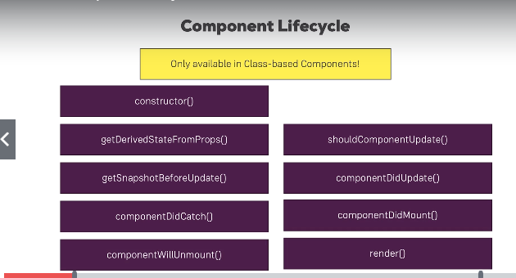

We have these methods in class based components and react will execute them in different points of time.

Order of execution. First we talk about component lifecycle for creation.

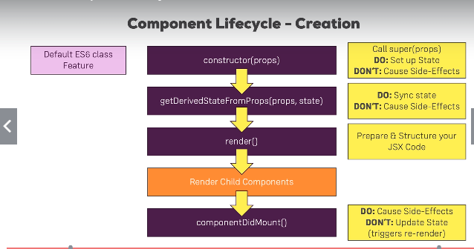

1. First the constructor will get called with the props.(This is a ES6 feature) If you have declared your own constructor then you need to call the super(props). Here we can set up the initial state and here we should not write any http requests as it will again render the lifecycle.

2. getDerivedStateFromProps(props, state) this is a new feature introducded in react 16.3 where this is not used a lot. This is rarely used. Here if there are any changes to the props for the compoenent then we can sync the state accordingly.

3. render() – this is where we prepare and structure our JSX code.

4. Render Child Compoenents – if there are any child components, the entire lifecycle will repeat for that component also.

5. componentDidMount() – this will be called only when all the child and parent lifcyles are completed. Here we can cause side effects. This is where we can use http requests to get data from the web. Here we should not call the setState() unless it is in .then .catch() blocks of a promise after we call a HTTP request. We can setState() asynchronously when we fetch data from HTTP but not immediately after the function gets called.